**ECE496 Proposal**

| **Project Title** | Physics-based machine learning models for indoor wireless localization |
| --- | --- |
| **Project Number** | 2021415 |
| **Supervisor** | Costas Sarris |
| **Administrator** | Tome Kosteski |
| **Name of students** | Prerna Anand  John Adrian Ambrad  Hiranya Maharaja  Deeksha Tewari |
| **Date of submission** | 20th September, 2021 |

**Executive Summary**

Indoor localisation systems locate a person or object within a building or other enclosed spaces. The systems’ uses range from helping firefighters conduct search and rescue in an emergency, to customising discounts based on the location of a customer, to allowing indoor robot assistants to map their surroundings better. Presently, the problem of indoor localization has not been solved in a cost effective way with high accuracy. A variety of solutions have been explored which utilize both hardware and software that are either too costly or do not provide granularity (i.e., accuracy) of location. This leads to the need for a system that is easily deployable, accurate, and cost-effective. The proposed solution is to leverage machine learning techniques in order to predict a target’s location using its received WiFi signal strength (RSS), which would eliminate the hardware costs and make it easy to deploy.

Similar to the previous teams that worked on this project, we will be limited to the eighth floor of the Bahen building, as indoor localisation is heavily dependent on the location. We will achieve localisation in two steps. First, by implementing WiFi fingerprinting using two Raspberry-Pis to collect the testing data and the Ray Tracer provided by the supervisor to collect training data. Then, we will train a machine learning model based on the fingerprinting data and the research of the previous team as well as our own.

The team has divided the work into phases of two week time slots to complete major milestones such as data gathering and algorithm design. The team has been broken up into groups based on each individual’s strengths to work on multiple tasks simultaneously.

This project builds on the work of two previous teams, it is crucial for the team to understand the current position of the project to meet the objectives for the accuracy gains, and avoid repeating previous teams’ mistakes. The project also demands technical skill in ML, Raspberry-Pis, and modeling data from the ray tracer. Everyone in the team has varying degrees of experience in creating ML models and using Raspberry-Pis, so we will be dividing the work based on the expertise of individual team members.

There are also several risks associated with this project. One risk is we may experience delays if we code many potential models. However, we can mitigate this risk by ensuring prior research on each of the models to narrow down the list. Another risk is that if COVID-19 worsens, we will have to fully rely on the data collected using the Ray Tracer. Finally, we may have to spend some more time ensuring that any discrepancies between the Raspberry Pi and Raytracer data can be resolved.

# **Table of Contents**

**Table of Contents** **2**

**Background/Motivation** **3**

**Problem Statement** **4**

**Project Goal** **4**

**Scope of Work** **4**

**System Context Diagram** **5**

**Requirements Specification (preliminary)** **5**

**Project Milestones** **6**

**Feasibility Assessment** **6**

Skills and Resources: 6

Risks and Unknowns: 7

**Conclusion** **7**

**References** **7**

# 

# **Background/Motivation**

Indoor localisation systems locate a person or object within a building or other enclosed spaces, with uses ranging from helping firefighters conduct search and rescue in an emergency, to customizing discounts based on the location of a customer, to allowing indoor robot assistants to map their surroundings better. [1]. Industry and academic have proposed solutions ranging from custom hardware setups (relays, Bluetooth beacons, magnetic resonators or ultrasound speakers) to so-called “infrastructure-free”[2] setups using WiFi, however no solution has been developed that can provide high granularity (accuracy) in localising an object indoors that is cost effective and easy to deploy.

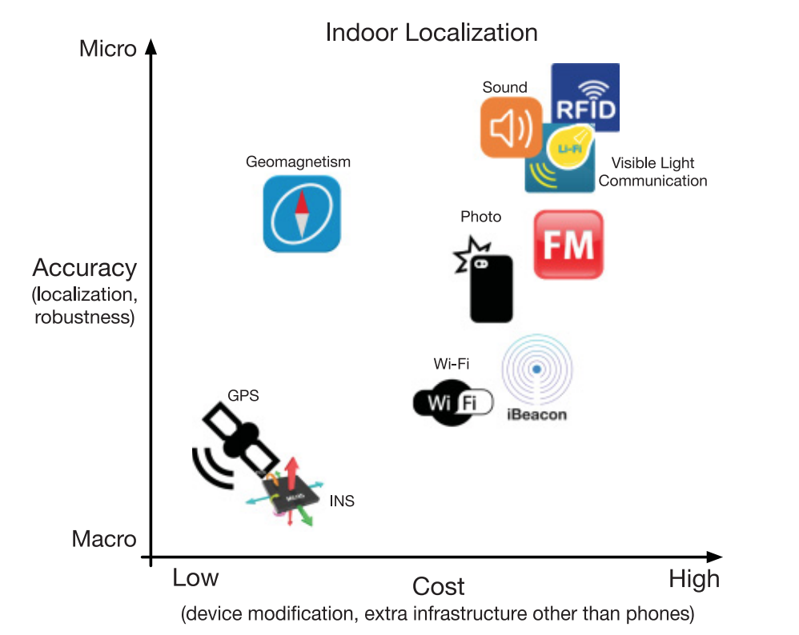

*Figure 1: Graph illustrating the cost vs accuracy effectiveness of various solutions proposed to the ILS problem [3].*

Compared to other technologies, Wi-Fi has become ubiquitous in most indoor spaces and does not rely on complicated hardware setups - therefore it is the ideal candidate to conduct indoor localisation with [2]. Machine Learning techniques are now being leveraged to solve the Indoor Localisation Problem by using WiFi received signal strength (RSS) data to predict location - two teams before our own have tried applying ML models to these problems - however the models produced are either lacking in accuracy or require a high cost to implement[1].

# 

# **Problem Statement**

There is currently a need for a system that is easily deployable, accurate, and cost-effective that wirelessly tracks static objects/assets within an indoor environment.

# **Project Goal**

The goal of this project is to create a machine learning model that accurately predicts the location of a static object in a specified environment, based on the WiFi signal strength (RSS) received by it.

# **Scope of Work**

Indoor localisation relies on the location's dimensions and structure, so we will be limited to one specific location – given that previous projects focused on the eight floor of Bahen, we will continue to perform localisation for that location only. To achieve a cost effective solution, we will be relying only on WiFi.

The project can be divided into two parts; WiFi fingerprinting and building the machine learning model. To implement WiFi fingerprinting, we will collect data using two Raspberry-Pis and the Ray Tracer.

* **Training data:** We will be using a Ray Tracer provided by the supervisor to simulate the signal strength in multiple locations
* **Testing data:** We will be using the Raspberry-Pis where one will act as access points to broadcast a signal and the other will receive the signal at a specified location. We will measure the signal strength received as well as its x and y location

We will use the research of the previous teams, along with our research, to build the machine learning model. The data collected will be used to train the machine learning algorithm that will predict the cartesian coordinates of the receiver based on its Received Signal Strength.

# **System Context Diagram**

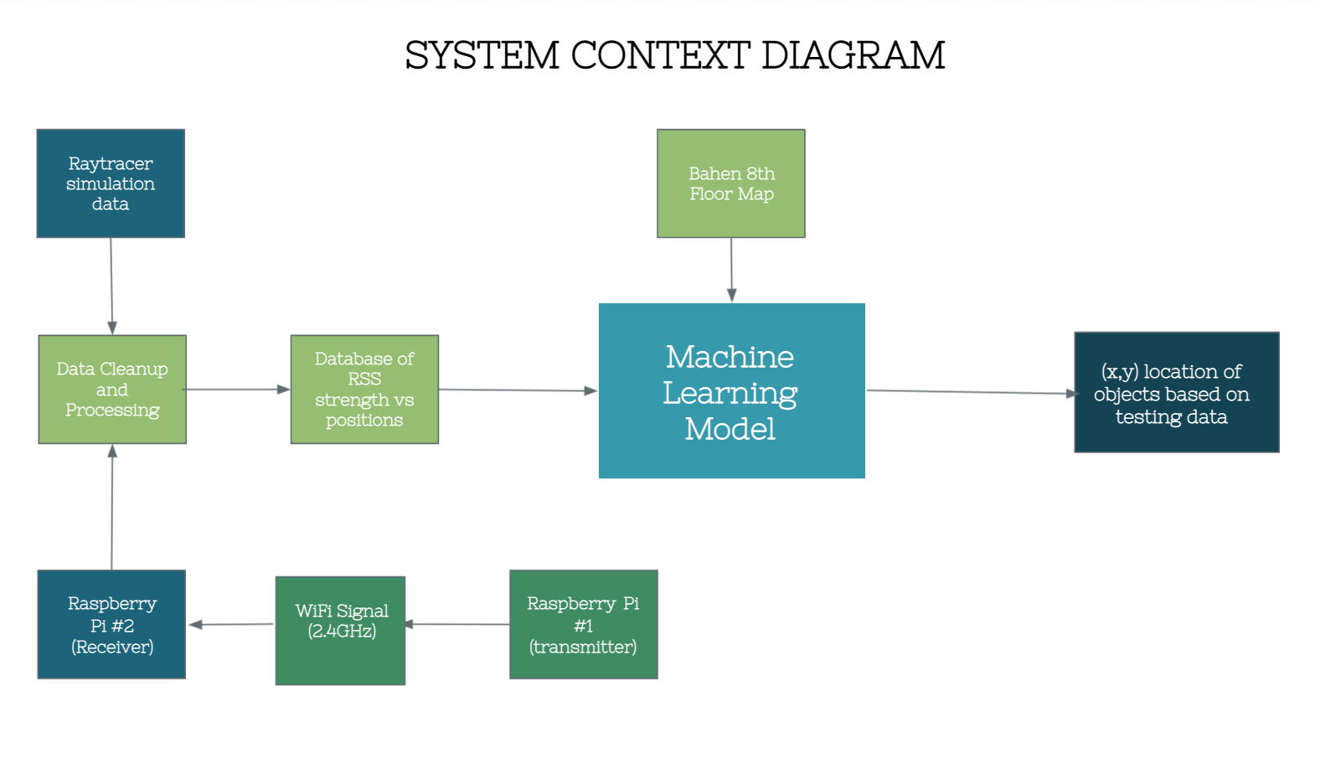

*Figure 2: System Context Diagram illustrating the inputs and outputs of our proposed system.*

# **Requirements Specification (preliminary)**

| **ID** | **Project Requirement** | **Description** |
| --- | --- | --- |
| 1 | Location in x-y coordinates of a static target given a WiFi signal strength (RSS) | **Functional Requirement:** this is the output specification of the project. |
| 2 | Data collection can only use RSS (received signal strength) | **Constraint:** Other methods are not feasible given their large expense and training requirements. |
| 3 | Map of Bahen Building | **Constraint:** Other buildings have thicker walls which will interfere with the collection of accurate data. |
| 4 | Raspberry Pi Router | **Constraint:** We cannot run the risk of disrupting UofT routers and need to test using our own. |
| 5 | Predictions should be less than 4 metres from the actual target | **Objective:** this would be an improvement on the previous teams’ margin of error. |

# **Project Milestones**

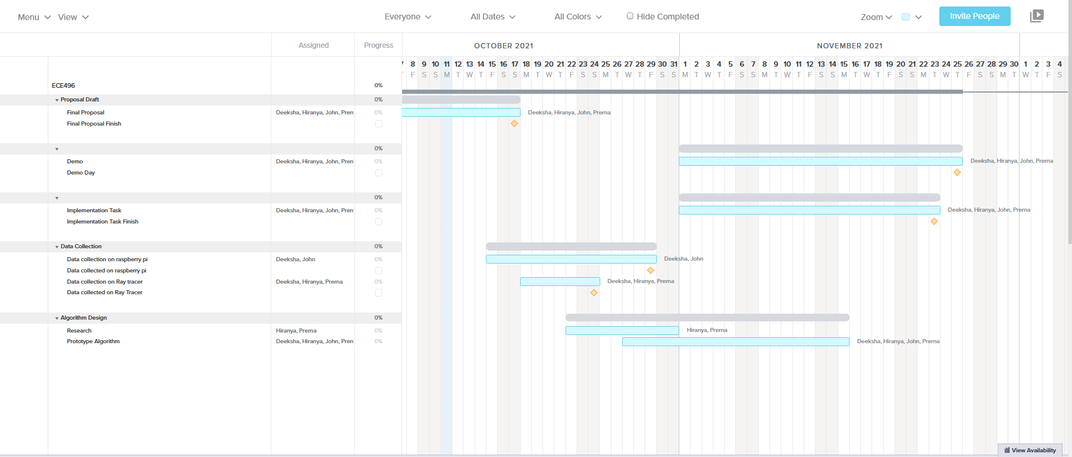

# **Feasibility Assessment**

## **Skills and Resources:**

This project builds on an existing project, so the team has taken steps to understand the literature and previous work done. By scheduling bi-weekly meetings with the supervisor we have established that we have sufficient knowledge of the problems encountered in the past, the work done until now, and the objectives going forward.

The project also demands technical skill in ML, Raspberry-Pis, and modeling data from the ray tracer. Everyone in the team has varying degrees of experience in ML and creating models, which we will use AI to locate a target given the WiFi signal. However, since two of four members have less experience with creating ML models, we will work in sub-teams to allow the more experienced members to help with the models when needed. We will also research and understand potential models together before coding them. For the Raspberry-Pis, we have already acquired enough of them to collect the data, and we also know how to use them. Finally, the ray tracer uses softwares such as Paraview, which we have downloaded and tested the sample files provided to us on, but we will also be in contact with the supervisors’ grad student to properly understand how to process and visualize data with it so we can test our ML model**.** To obtain the data we will use in our models, having access to Bahen’s 8th floor is a necessary resource, which we currently have.

## **Risks and Unknowns:**

There are three primary risks associated with this project, and ways that we can mitigate each of them. First we may lose time on coding the models, especially if we find many potential models. However, we can mitigate this risk by ensuring prior research on each of the models to narrow down the list of what might fit our data best and work on multiple models concurrently (by splitting into sub-teams).. Another risk is that we may lose access to Bahen’s eighth floor if COVID-19 worsens before we finish collecting data, in which case we would create our model using only the ray tracer data that was already collected. Finally, since the previous team was unable to do in-person data collection, we do not have any estimate of the discrepancies between the Raspberry-Pi data and the ray tracer data. Combining them might make the model less accurate. In this situation, we will not use the Raspberry-Pi data, and instead collect more with the Ray Tracer to make up for the data loss.

# **Conclusion**

The problem of localisation is typically solved with complex hardware and software in order to lock onto targets. However, we aim to provide a solution that uses deep learning models that can accurately locate a static target within certain thresholds primarily using the RSS of the wifi signals. We will do this by training the machine learning models on a combination of simulated signals and real world signals collected using the Raspberry-Pis.

# **References**

[1] Roy, P., Chowdhury, C. A Survey of Machine Learning Techniques for Indoor Localization and Navigation Systems. J Intell Robot Syst 101, 63 (2021). <https://doi.org/10.1007/s10846-021-01327-z>

[2] D. Lymberopoulos and J. Liu, "The Microsoft Indoor Localization Competition: Experiences and Lessons Learned," in IEEE Signal Processing Magazine, vol. 34, no. 5, pp. 125-140, Sept. 2017, doi: 10.1109/MSP.2017.2713817.

[3] HE, S. and G. SHIN, K., 2017. Geomagnetism for Smartphone-Based Indoor Localization: Challenges, Advances, and Comparisons. [online] Dl.acm.org. Available at: <https://dl.acm.org/doi/pdf/10.1145/3139222> [Accessed 12 October 2021].